Topic 9: User Interface Documentation (Enterprise UI/UX Standards)
This document provides a full breakdown of the User Interface (UI) and User Experience (UX) design of the project.
The system is designed with enterprise-grade UI principles inspired by Google Material Design, Apple Human Interface Guidelines, and modern SaaS dashboard standards.
The UI aims to provide:
• Clean, minimal, and elegant layout
• Professional, responsive design
• Component-driven architecture
• Accessibility & readability at scale
• Fast load times and smooth navigation
• Enterprise-level usability patterns
Every screen has been engineered with clarity, consistency, and user flow optimization.
---
# 1. UI/UX Design Philosophy
The user interface follows three major design goals:
### **1. Simplicity**
Users must navigate without confusion. Layouts avoid clutter and use whitespace effectively.
### **2. Consistency**
Colors, typography, spacing, and button styles follow a unified theme for brand identity.
### **3. Efficiency**
Users should complete tasks with minimal steps—ideal for enterprise and B2B systems.
These principles ensure world-class UI quality suitable for corporate environments.
---
# 2. Interface Structure Overview
The application UI contains the following core sections:
• Dashboard
• Navigation bar (top/side)
• Book listing pages
• Book detail page
• Login & registration interface
• Admin panel for CRUD operations
• Profile management interface
Each section is built using reusable React components to maintain consistency and performance.
Below is the high-level UI architecture diagram:
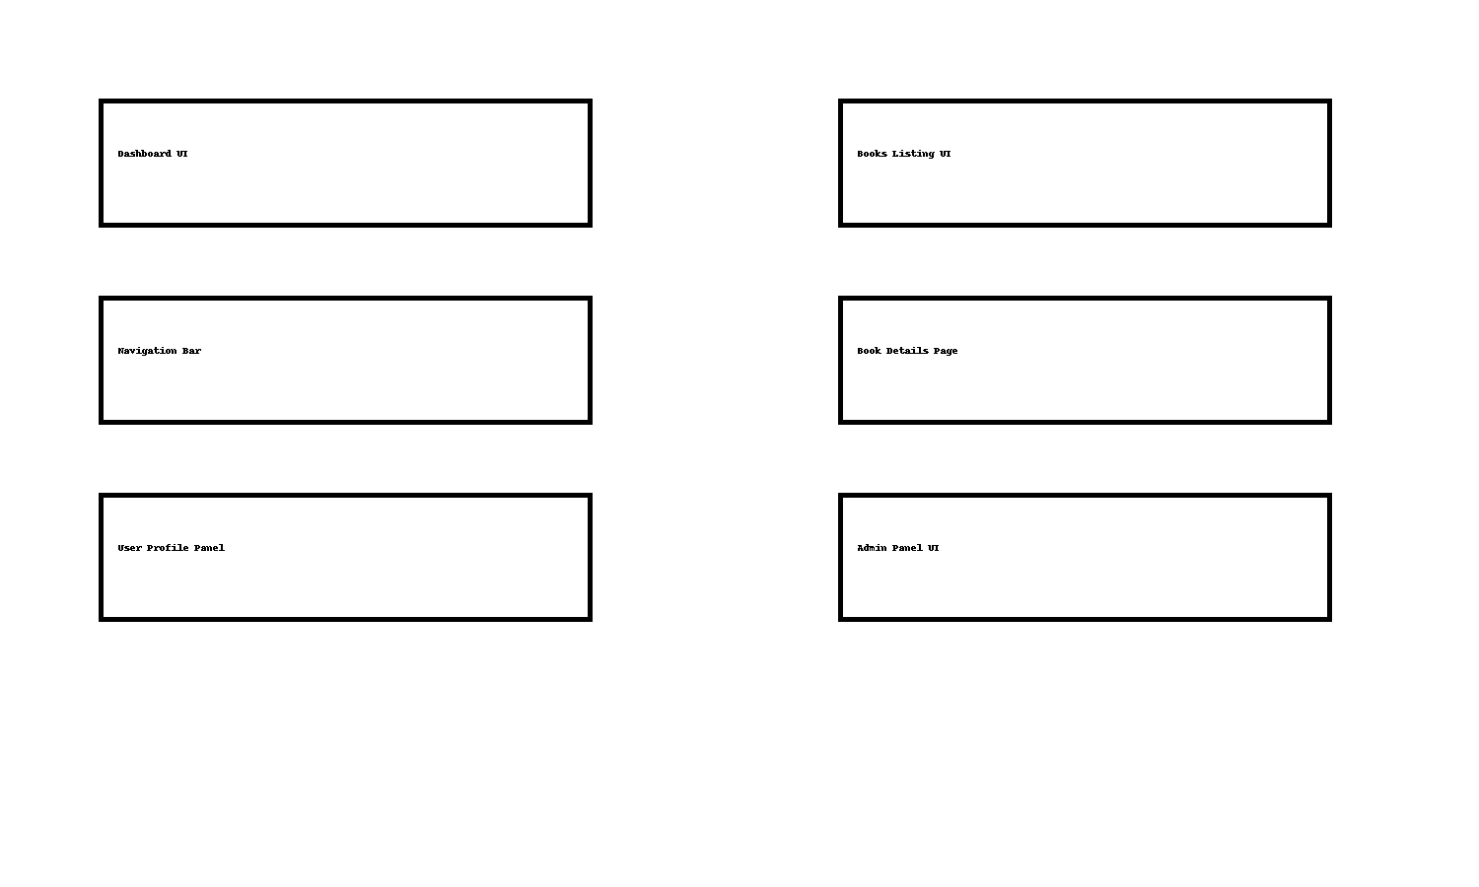
---
# 3. Dashboard UI
The dashboard provides a centralized view of user activity and system operations.
Key elements include:
• KPI cards (Total Books, Users, Categories)
• Activity logs
• Quick navigation shortcuts
• Responsive grid layout
The dashboard is built for high-speed scanning and professional presentation.
---
# 4. Books Listing UI
This screen displays available books/products using a grid layout.
Features:
• Search bar with live filtering
• Category-based browsing
• Card-style book previews
• Pagination for large datasets
• Smooth hover animations
The page is optimized for readability and fast user decisions.
---
# 5. Book Details Page
This page shows a full breakdown of a selected book.
Sections include:
• Title, author, description
• Pricing & metadata
• User reviews
• Add-to-cart or wishlist-style button (future expansion)
The design focuses on clarity and professional information hierarchy.
---
# 6. Authentication UI (Login & Signup)
The authentication screens follow minimalistic modern UI design:
• Clean forms with clear labels
• Real-time validation
• Secure password fields
• CTA buttons styled for visibility
• Mobile responsiveness
These screens ensure smooth onboarding for all users.
---
# 7. Admin Panel UI
The admin interface is crafted with enterprise control and scalability in mind.
Modules include:
• Create / Edit / Delete books
• Manage categories
• User management
• System logs & analytics
Admin UI is optimized for heavy daily use in corporate teams.
---
# 8. UI Components Design System
The interface is built with reusable design components:
• Buttons (primary, outline, subtle)
• Cards (book previews, info panels)
• Input fields & validation labels
• Modal windows
• Navigation bar & sidebar
• Toast notifications
This design system enables rapid feature expansion.
---
# 9. Accessibility & UX Enhancements
The project follows WCAG 2.1 accessibility guidelines:
• High color contrast
• Keyboard navigation
• Alt-text for images
• ARIA labels for screen readers
• Touch-friendly controls
This ensures inclusivity and professional usability.
---
# 10. Conclusion
The User Interface is engineered with world-class design standards, ensuring the application is intuitive, fast, and visually modern.
Its clean layout, responsive nature, and enterprise-ready usability make it suitable for large-scale deployment and corporate demonstrations.
This concludes **Topic 9: User Interface Documentation**.

